Angelos Michalopoulos
ITC 4380
17/07/2025

Question 1: Logic & Inferencing Report

For the first question of the final project, I created a logic based diagnostic algorithm that can diagnose problems in an engine according to the user’s selection of symptoms that are taken from a specific knowledge base. Based on those symptoms the code has to identify the fault that is the most likely to have caused the symptoms the user is experiencing. After identifying the fault, the code has to ask the user to perform a test so determine if the fault is correctly identified, followed by an action to remove the fault.
In order for me to be able to complete everything that the project required and complete the task of the question, I created multiple functions that each perform different things during the execution of the code. The functions are the following, the KB dictionary, the load_kb function, the update_executions function, the get_symptoms, the find_minimum_candidates function which includes a nested backtracking function, the calculate_likelihood function, the sort_candidates function, the choose_fault function and lastly the logic_loop function and the main function. The code starts with the function that is in charge with loading the KB txt file in the KB python dictionary which is handled by the load_kb function. The load_kb function has multiple if statements that check with what words each line in the KB starts with and places all the corresponding information in the correct dictionary position so that the code can use it for the diagnosis process. The next function, the update_executions function, updates the number of executions that the program performs, which also affects the probability of each fault in the sorting process. This is followed by the get_symptoms function which has the argument of the fault_set, which are all the faults of the KB that are relevant and are taken from the fault_set. From a “for loop” it sees all the symptoms that are caused from the specific fault_id the loop is currently examining, as long as the fault_id exists in the KB. Moving on the calculate_likelihood and sort_candidates functions are performed, which are responsible on deciding the order of which the minimum candidates are given to the system. Firstly, the calculate_likelihood function calculates the probability of each fault using the instructions of the project. The function also calculates the number of faults each candidate has, in which the lesser the better, as well as the number of unobserved symptoms for each candidate set that has been generated. These two numbers are going to be used as tie breakers when the code actually sorts the sets, which is performed by the sort_candidates function and which return the sorted set of candidates based on the instructions of the project on how to sort them. The following function described is the choose_fault function, which chooses the best fault that explains all of the symptoms that the user has stated they observed in the start of the system. This is done by getting the sorted candidates set and by examining each fault from the first candidate set and seeing how many of the symptoms from the set of observed symptoms it explained, finally choosing it as the best fault to test. Next the logic_loop function is the function that runs the main system of the project. Firstly, it shows the user all of the symptoms that appear in the knowledge base with the id of each symptom and their matching description. The function then asks the user to choose the symptoms that are observed. After seeing if the ids of the symptoms are valid it calls the function that finds the minimal candidates and creates a set of candidate lists that are minimal. The next thing this function executes is that it calls the function that sorts the candidates that are found in the previous step and then chooses the best fault from the first set of candidates that it just sorted. After it has chosen the best fault, it asks the user to perform a test to see if the fault was present in the engine. The test is taken from the knowledge base where each fault has a test that corresponds to it and the code selects the appropriate test. The code then waits for the user to input whether the fault was present or not, and if the fault was not present the fault is put in the non-applicable set in the knowledge base. If the fault is present, then the code changes the number of appearances that the fault has in the KB and then asks the user to perform an action that corresponds to the fault. For example, if the symptom is “car wont start” the fault could be “no fuel”, the test would then be “see if the car has fuel” and the action would be “fill the car with fuel”. After that is completed, the system puts the tested fault in the non-applicable set. The last thing the loop does is it asks if the user observes any other symptoms, if the previous symptoms persist, or if any new ones have appeared and accordingly the loop either starts again, or it ends.
The last function I will describe is the most important function in the entire code, which is the function that is in charge of the generation of the minimal fault candidate sets. A minimal fault candidate is a list of candidates that explain all the symptoms that the user observes. What makes it minimal is that if you remove one single fault from the list of candidates then the new list will not be able to explain all the symptoms and so that list of candidates will be useless. In order to tackle this problem, I thought of the candidate set as a hitting set, so I have to find the minimum hitting set compared to the set of observed symptoms. To do this, I first generate all the hitting sets (using backtracking) and filter the generated sets for minimality. This is achieved from the following code:
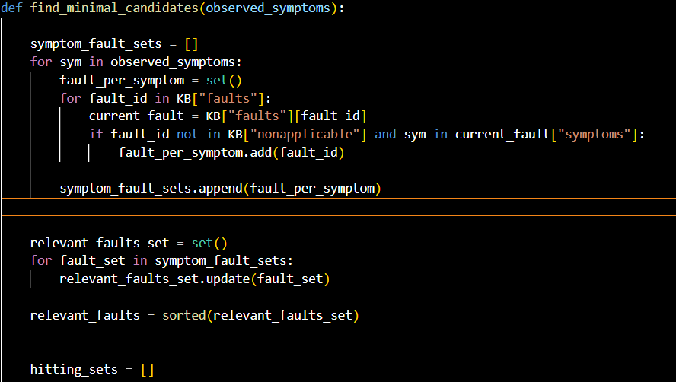
In the screenshot above the find_minimal_candidates function gets the argument observed_symptoms which is a set that has a list of all the symptoms that the user can observe in the engine. With this information, I create a list called symptom_fault_sets wich is meant to represent a list of all the faults that can correspont to one symptom. For example in a list with two symtpoms {1,2}, symptom_fault_sets could be something like this {[1,2,3],[2,3]} which means symptom 1 can be caused by fault 1, 2 or 3. In order to fill in this list I do a “for loop” for each symptom in the observed symptoms list, another “for loop” that sees for all fault ids in the knowledge base that states all the information of the current fault, based on the fault id we are cerently examining in the loop. This is achieved through the line “current_fault =KB[“fault”][fault_id]”. Afterwards using an “if statement” the code checks if the fault_id is not in the non-applicable set and if the current symptom we are examining from the observed symptoms exists. If both of those statements are met then that fault id is added in the fault_per_symptom set. After all the symptoms from the observed symptoms are checked, the code appends the fault_per_symptom set to the symptom_fault_set list, then I write a loop that takes all the unique fault ids from the symptom_fault_sets list and sorts them so that the relevant_faults set can be {1,2,3,…).
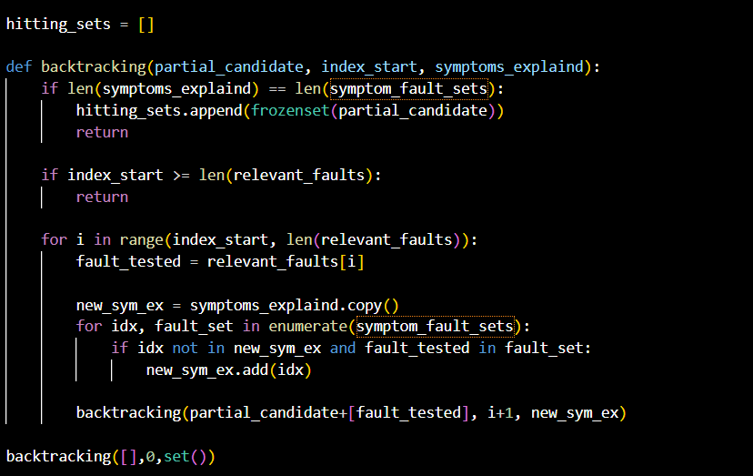
The above screenshot depicts the nested backtracking function which is responsible for generating the candidates which afterwards are filtered in terms of minimality. In order to find the minimal candidates I thought of seeing them as hitting sets. A hitting set of a collection of sets is a set that intersects with every set in the collection, and a minimal hitting set is a set where if you remove one part of the set it stops being a hitting set. This maps perfectly the minimal candidate problem of the project. For the code, I started by creating a list of all the hitting sets that the backtracking fucntion generates. The backtracking fuction gets three arguments, partial_candidate which is the set of faults currently being tested to see if it is a hitting set, then there is the index_start which is important for the loops used in the recursion and finally the symptoms_explained set which shows the indexes of the symptoms the fault explains (for example if {[1,2],[2,3]} are the faults explained for symptom 1 and symptom 2 respectively and the loop is looking at fault 1 the symtpoms explained set whould be {0} but for fault 2 it whould be {0,1}). In the nested function the code firsts asks if the number of symtopms explained is the same as the number of sets in the symptom_fault_sets list. If it is the same it means that all the sets are explained and that the set is a hitting set and so the code stores the partial candidate to the hitting sets list (as a frozenset so that when it is turned back into a normal set a lot of the duplicates are removed since frozensets help avoid duplicate combinations even if the fault ids are in a different order so [1,2] and [2,1] becomes [1,2]), and the fucntion returns. The nested if statement is to see if the index start is equal or larger that the number of relevent faults which means that the recursive function has completed the loop for as many or more faults as there are available without finding a hitting set so the path stops and it recursively returns to the previous call of the function. Lastly for the bactracking recursive function I use a “for loop”. In this “for loop” I do it for “i” in the range of (index_start which in the beginning is 0 to the number of relevant faults). There, depending on which iteration of the loop we are using, we store the relevant faults we want to test and add in the partial candidate. Then I copy the symptoms explained set (because it is a set and it whould change for all levels of the recursion). Afterwards I do another “for loop” where it checks if the indexes of the symptom_fault_sets list exists in the new_sym_ex and if the fault_tested exists in the fault set of the symptom_fault_set list. If both are true then the symptoms explained are updated and the function is called again with a new partial_candidate, and the index is incremented by 1 (which makes the range of the loop start smaller and forces the loop to start with the next fault) and with the new_sym_ex set() and the process starts again until either the path leads to a hitting set or it runs out of faults which then returns to the previous layer of the recursion, continuingbuntil it can generate all the candidates.
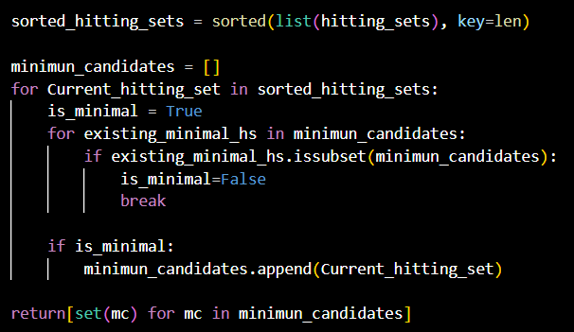
Finally, the last part of the find_minimal_candidates function is finding the minimal candidate from the candidates that the code genarated. Firstly the code sorts the hitting_sets list found previously, with a key of len which is based on the length of the set. I then create a minimum_candidates list which will store the minimal candidates of the diagnositics system. Then I perform a “for loop” for all the hitting sets I found previously. In this loop I name a boolean value, is_minimal = true, which is meant to show if a hitting set is minimal or not. Then using the list I just created a made a “for loop” that sees if the existing minimal hitting set is a minimal candidate, which is shown by comparing the candidate on if it’s a subset of any of the sets in the minimun candidates list. For the first loop since the list is empty the if statement is not trigged. After the loop ends there is an if statement which sees that if the is_minimal boolean has remained true then the last hitting set the code examined is actually minimal and so it is appended in the minimum candidate list.

The following screenshots are screenshots that show the execusion of the program for symptoms 3,4: 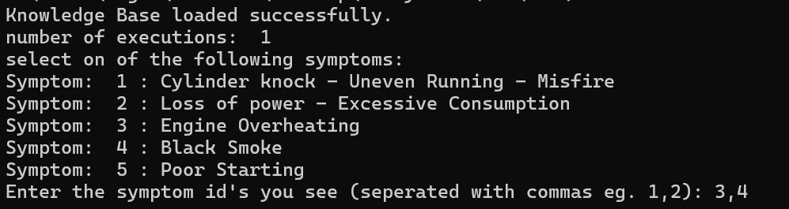 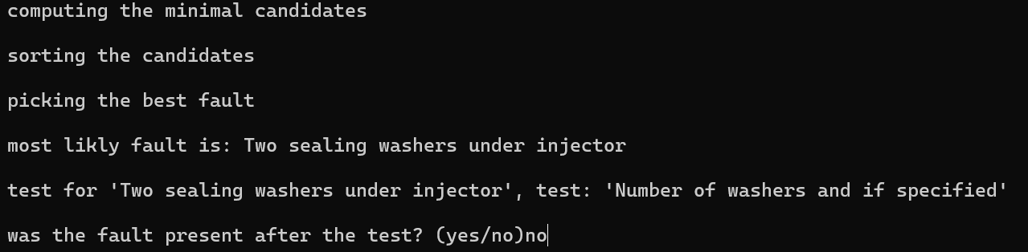
This is what happens if the user writes “no” on if the fault was present. 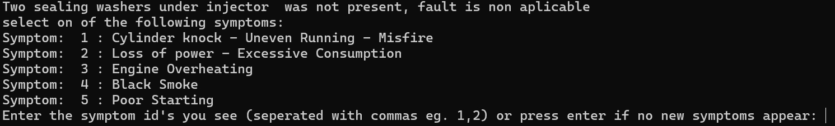
Since the fault was not present lets say that the user still sees the same symptoms (3,4). 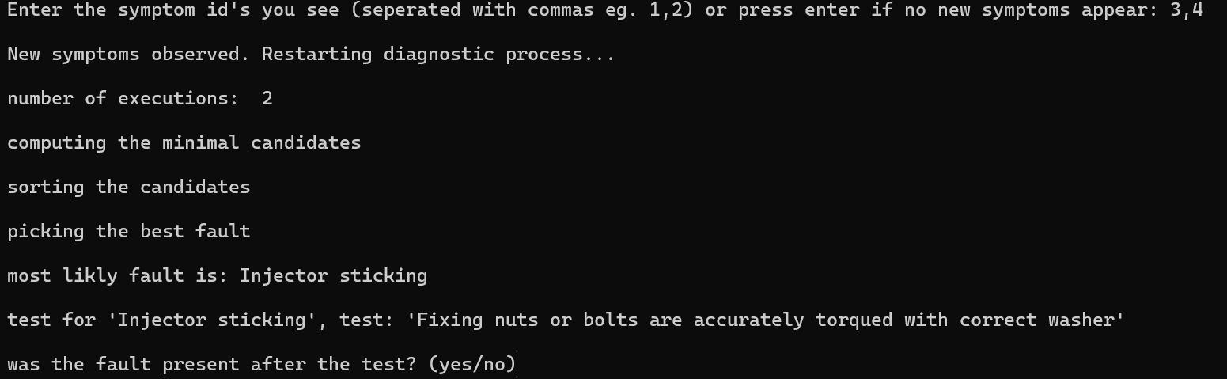
Now lets say that the fault was present. 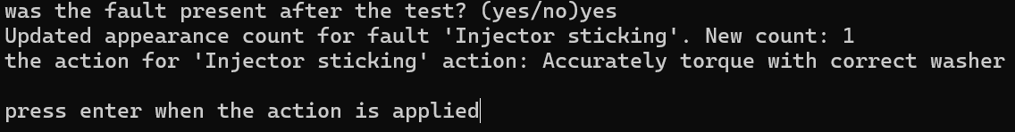
Then the user presses enter to say that they have performed the fault test.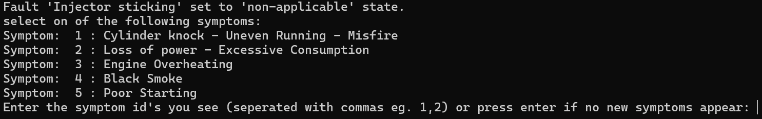
And no new symtpoms are present so the user presses enter again.

Question 2: Prediction Task Report

For the second question of the final project, I had to evaluate a classification model for a medical dataset that is supposed to be able to predict a patient’s disease (the classes) based on the patient’s symptoms from a dataset which is the dermatological dataset from UC Irvine machine learning repository. The dataset has 35 features 34 of which are the inputs that determine the class of the row (which is the 35th feature and it is separated into 6 classes). Out of the 34 features 33 of them (the symptoms) are linear valued while one of them is nominal which is the family history attribute that is binary with values of 0 or 1. The preprocessing I did for the project was turning the dermatology.data file into a csv file and then, using the dermatology.names file give the features there correct names since before the dataset didn’t have a table header. The above is done for the sake of better readability in the dataset and the model. The next thing I had to do for the preprocessing of the data was decide what I would do with the missing values in the data set. Since I will be using Weka in order to train the model and Weka can handle missing values as long as the missing values have the value “?” (which is true for the dermatology dataset), this means that the model will not have a problem handling the missing values and therefore I can proceed with training the model. As mentioned above I will use the Weka library in order to train the model. The problem is a classifier problem so that means in order to be able to work I have to turn the class feature from numerical too nominal that that is achieved by using a filter called NumericaltoNominal. Once that is achieved, I can move on with actually training my model. To train the model I choose the multilayer perceptron (the neural network) option from the model option of Weka. From the available testing option, I chose to use the cross validation testing method with 5 folds. The way the cross-validation works is it separates the dataset to a k-number of folds, in this case 5 and uses one as a test dataset and the other as training and after it has done that it moves to the next fold as the training dataset and the remaining folds are turned into the training dataset. The parameters that will be tuned for the model are, the learning rate (L) which had a default value of 0.3, the momentum (M) which had a default value of 0.2, the number of epochs (N) which had a default value of 500 and lastly the hidden layers. In the last parameter you can also choose the number of hidden nodes in each layer which had as a default parameter one hidden layer and for number of hidden nodes it had “a” which is the number of attributes plus the number of classes divided by 2 so in this particular dataset it is 20. After a number of experiments, I found that the best parameters where the following. L:0.1, M:0.1,N:200,V:0,S:0,E:20,H:i. For both the learning rate (L) and the momentum (M) parameters I noticed that when they would increase, the accuracy would either remain stagnant or it would decrease so I decided to lower both originally to 0.01 which is a very small L and M. Afterwards, I started with a smaller number of epochs (N) compared to the default ,200 instead of 500) and originally the accuracy of the model fell a lot so I decided to increase the L and the M both to 0.1 and that provided the best model so far with only 8 wrong predictions. For the hidden layers, as well as the number of hidden nodes, I started by lowering the number of nodes from a(20) to 5 which caused the accuracy to drop and then I increased the number of layers to two, again with 5 nodes each, and it once again caused the accuracy to drop so I went back to one hidden layer and chose to use i which is 34 nodes and this had the best accuracy 98.0874 %.
Best model (l:0.1, M:0.1,N:200,V:0,S:0,E:20,H:i)
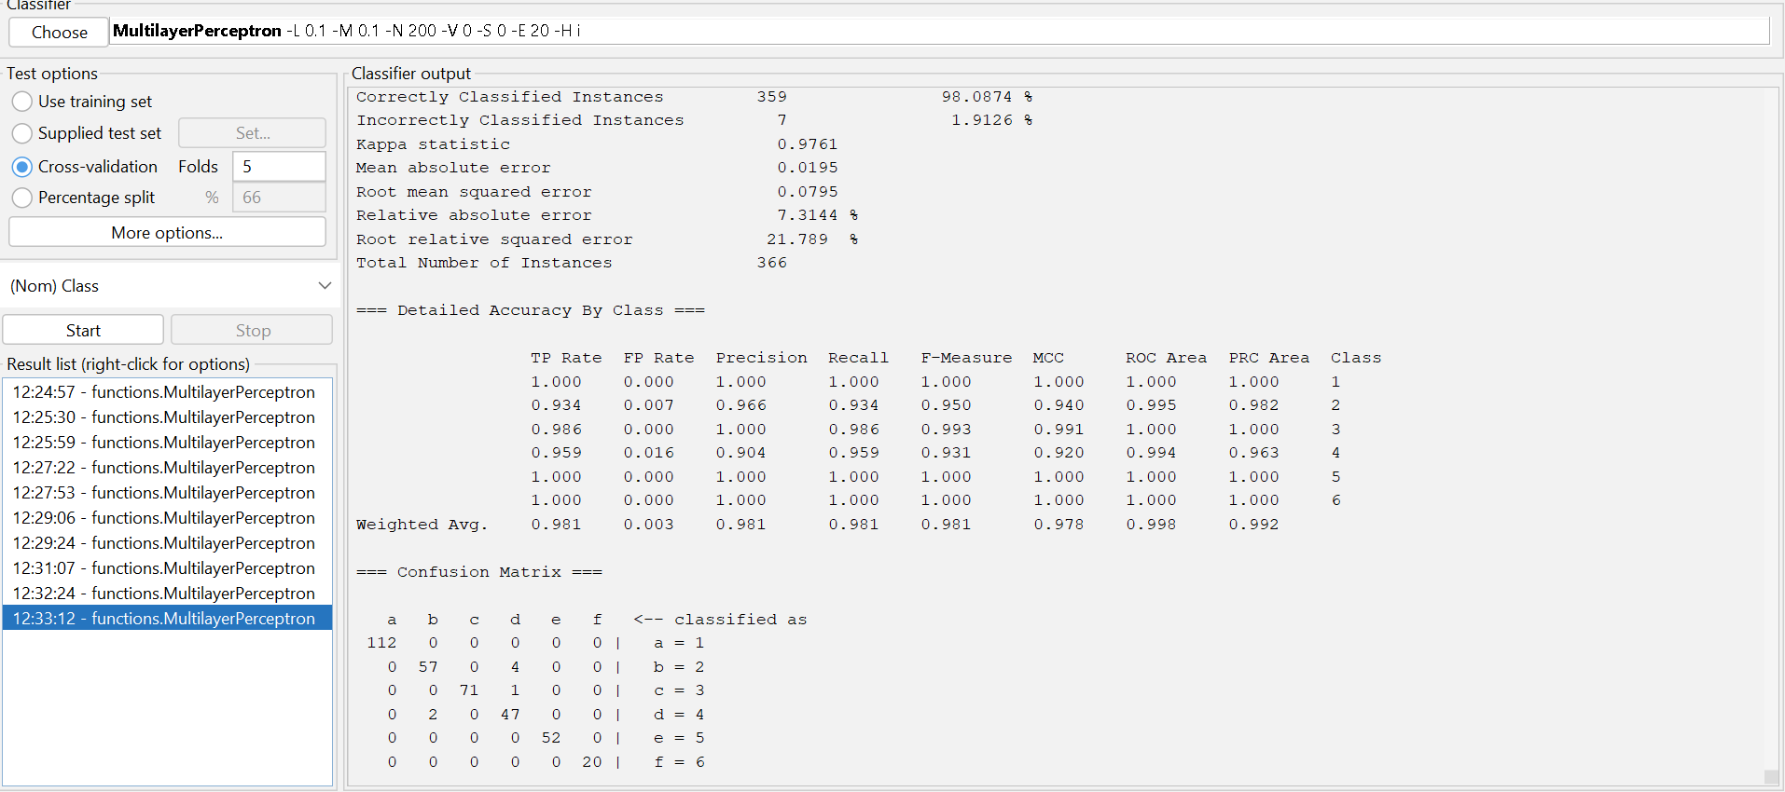
From the screenshot above we can see both the confusion matrix and the performance metrics of Precision, which shows the percentage of correctly predicted values from all the values predicted in a class, recall, which shows the percentage of correctly predicted values from all the values of a class, as well as the F-Measures which is the combination of the last two metrics. First, we see that the weighted average for all of the three metrics is very good and since this average shows the average for the class with the size of the different classes in mind, we can see that it does show a good initial look for the model. This is even further backed up by seeing the individual classes for all the metrics where the precision of all the classes, except class 2 and 4, are 100% which means that for most classes whenever they predict that something is in a class they are always correct. For the recall its almost the same, except that in addition to 2 and 4, class 3 also doesn’t have 100% which shows that while it is correct always when it predicts something as class 3 it can miss a value and not name it as class 3. Lastly from the confusion metrics we can see that the model not only struggles the most with class 2 and 4 but that the model has a hard time distinguishing them from each other since most of the time the wrong predictions come from mislabelling something from class 2 to class 4 and vice versa.
The following screenshots show the models for all the parameters that I tested for the model in the project:
